PROJECT REPORT

# AI-POWERED NUTRITION ANALYZER FOR FITNESS ENTHUSIASTS

TEAM ID: PNT2022TMID27357

Submitted by:

1. MALINI R - 311019106045
2. SRIMAN NARAYANAN P G - 311019106066
3. NISHA RASAILI - 311019106045
4. MATHANGI SRIRAMAN - 311019106038

**TABLE OF CONTENTS**

1. **INTRODUCTION**
   1. PROJECT OVERVIEW
   2. PURPOSE
2. **LITERATURE SURVEY**
   1. EXISTING PROBLEM
   2. REFERENCES
   3. PROBLEM STATEMENT DEFINITION
3. **IDEATION AND PROPOSED SOLUTION**
   1. EMPATHY MAP
   2. IDEATION AND BRAINSTROMING
   3. PROPOSED SOLUTION
   4. PROBLEM SOLUTION FIT
4. **REQUIREMENT ANALYSIS**
   1. FUNCTIONAL REQUIREMENT
   2. NON-FUNCTIONAL REQUIREMENT
5. **PROJECT DESIGN**
   1. DATA FLOW DIAGRAM
   2. SOLUTION AND TECHNICAL ARCHITECTURE
   3. USER STORIES
6. **PROJECT PLANNING AND SCHEDULING**
   1. SPRINT PLANNING AND ESTIMATION
   2. SPRINT DELIVERY SCHEDULE
7. **INTRODUCTION**
   1. **PROJECT OVERVIEW**

Food is essential for human life and has been the concern of many healthcare conventions. As the world grows more fitness-conscious with passing time, the demand for technological solutions to cater to this burgeoning demand is diversifying. Nowadays new dietary assessment and nutrition analysis tools using predictive analytics artificial intelligence and natural language processing enable more opportunities to help people understand their daily eating habits, exploring nutrition patterns and maintain a healthy diet. Nutritional analysis is the process of determining the nutritional content of food. It is a vital part of analytical chemistry that provides information about the chemical composition, processing, quality control and contamination of food.

* 1. **PURPOSE**

The main aim of the project is to building a model which is used for classifying the fruit depends on the different characteristics like colour, shape, texture etc. Here the user can capture the images of different fruits and then the image will be sent the trained model. The model analyses the image and detect the nutrition based on the fruits like (Sugar, Fibre, Protein, Calories, etc.).

1. **LITERATURE SURVEY**

**2.1 EXISTING PROBLEM**

**[1] Deep Food: Food Image Analysis and Dietary Assessment via Deep Model**

This system will analyse the nutritional ingredients based on the recognition results and generate a dietary assessment report by calculating the number of calories, fat, carbohydrate and protein.

**ALGORITHMS USED:**

• Region-based

• Convolutional Neural Network

• Non-maximum suppression

• Bounding Box Regression

• Deep learning techniques

**CHALLENGES:**

Three main challenges in real food image recognition and analysis are addressed as follows:

1. Region of Interest

2. The Delay of Food Recognition

3. Insufficient Information of Nutrition Content for dietary assessment.

**[2] A New Deep Learning-based Food Recognition System for Dietary Assessment on An Edge Computing Service Infrastructure**

It is a design of food recognition system employing edge computing-based service computing paradigm to overcome some inherent problems of traditional mobile cloud computing paradigm, such as unacceptable system latency and low battery life of mobile devices.

**ALGORITHMS USED:**

• K-means clustering algorithms

• Convolutional Neural Network

• Bounding Box Regression

• Deep learning

**CHALLENGES:**

Using this simple cropping-based approach will not work well if the food is scattered on different parts of the image.

**[3] Precision Nutrient Management Using Artificial Intelligence Based on Digital Data Collection Framework**

Nutritional intake is fundamental to human growth and health, and the intake of different types of nutrients and micronutrients can affect health. The content of the diet affects the occurrence of disease, with the incidence of many diseases increasing each year while the age group at which they occur is gradually decreasing.

**ALGORITHM USED:**

• Okapi BM25

• TF-IDF

• Levenshtein

• Jaccard

• Synonyms

**CHALLENGES:**

This model has very little error and can significantly improve the efficiency of the analysis.

**[4] Calculating Nutrition Facts with Computer Vision**

People are becoming more health-conscious than before. However, there is a lack of knowledge about different fitness and wellness aspects of food. Thus, I come up with Foodify. AI-a deep learning-based application that detects food from the image and provides information of food such as protein, vitamins, calories, minerals, carbs, etc

**ALGORITHM USED:**

• Deep learning

• Machine learning

• Image Processing

**CHALLENGES:**

1.This is to collect images to create a huge dataset.

2. This is related to training the deep learning model. It is an extremely computationally expensive and time-consuming task to train the model again and again. This can be solved by using cloud-based services

**2.2 REFERENCES**

* <https://ieeexplore.ieee.org/document/8998172>
* <https://scholar.google.co.in/scholar_url?url=https://ieeexplore.ieee.org/ielaam/4629386/8332642/7837725-aam.pdf&hl=en&sa=X&ei=df14Y6_5CZCXywTpjZ64Bw&scisig=AAGBfm30mwcC1DJ2XAFNUqxS-Jb7uSlfRg&oi=scholarr>
* <https://www.researchgate.net/publication/360084522_Precision_Nutrient_Management_Using_Artificial_Intelligence_Based_on_Digital_Data_Collection_Framework>
* <https://www.google.com/amp/s/towardsai.net/p/l/calculating-nutrition-facts-with-computer-vision%25E2%2580%258A-%25E2%2580%258Afoodify-ai%3famp=1>

**2.3 PROBLEM STATEMENT DEFINITION**

In India, this global trend has had a positive impact on scores of startups and websites catering to this segment. AI and its various subsets have been leveraged by these platforms to identify the calorie intake and also to make food recommendations for a healthy diet. In most cases, what we see is that these platforms act as a data repository where while providing real-time information to its users, it also makes available to numerous clients who work in this field for a determined rate. AI-based online platforms which make use of AI and other deep learning technologies to provide a real-time update about nutrition intake. The platform also further breaks down the nutrition information calories, macro and micronutrients as well as ingredients.

**IDEATION AND PROPOSED SOLUTION**

**3.1 EMPATHY MAP**

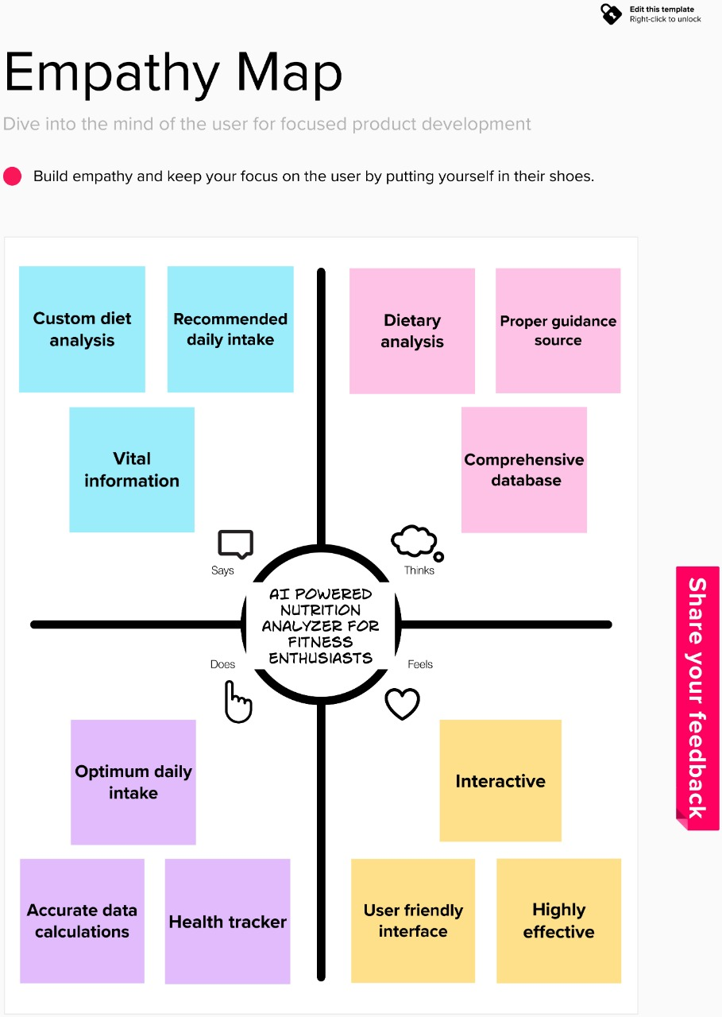

**3.2 IDEATION AND BRAINSTORMING**

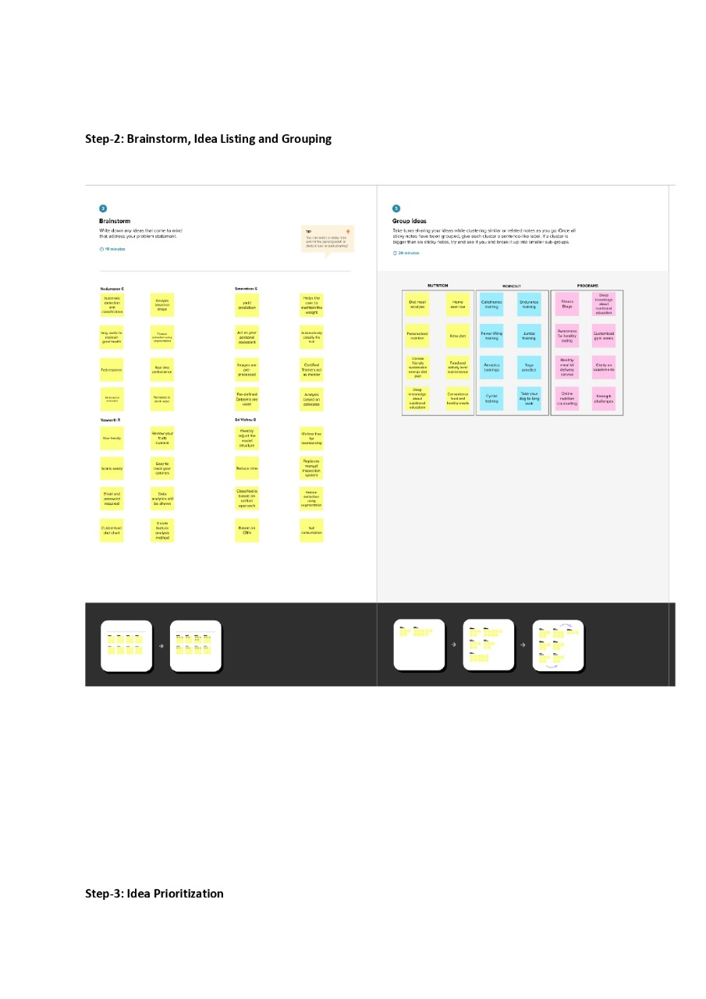

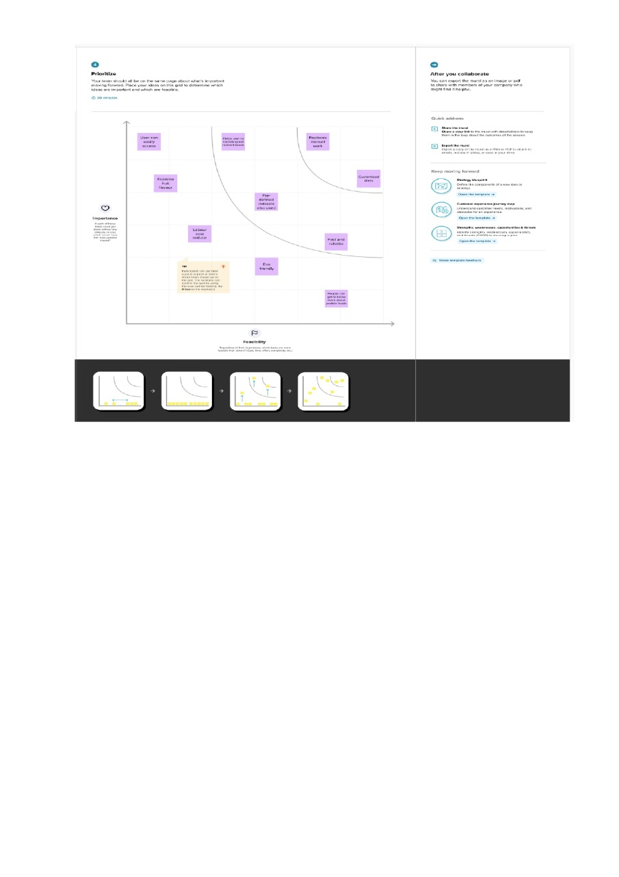

**3.3 PROPOSED SOLUTION**

|  |  |  |
| --- | --- | --- |
| **S. No.** | **Parameter** | **Description** |
| 1 | Problem Statement (Problem to be solved) | To help people understand their daily eating habits, exploring nutrition patterns and maintain a healthy diet. |
| 2 | Idea / Solution description | Building a model which classifies and analyses the image and detect the nutrition. |
| 3 | Novelty / Uniqueness | This model classifies the food depends on the different characteristics like color, shape, texture etc. |
| 4 | Social Impact / Customer Stisfaction | The Nutrition Analyzer can be applied in more than one sphere of life and used not only by athletes. It would be a great companion for those of us who decided to build a perfect body and can be successfully used in medicine and daily life as well. |
| 5 | Business model (Revenue Model) | This business model is restricted to a single owner. This model is a platform that is self-owned nutrition tracking mobile application. |
| 6 | Scalability of the Solution | The main advantage of this project is its scalability. It is very compact in size so that it will be very easy to use. |

* 1. **PROBLEM SOLUTION FIT**

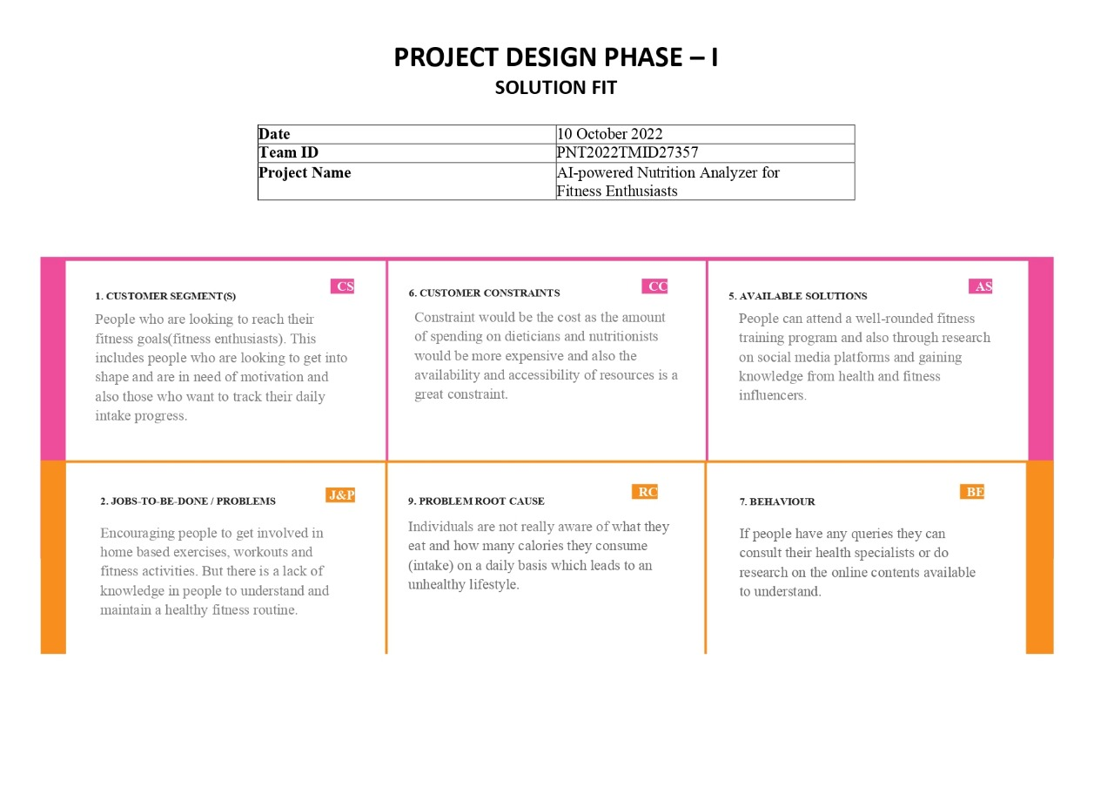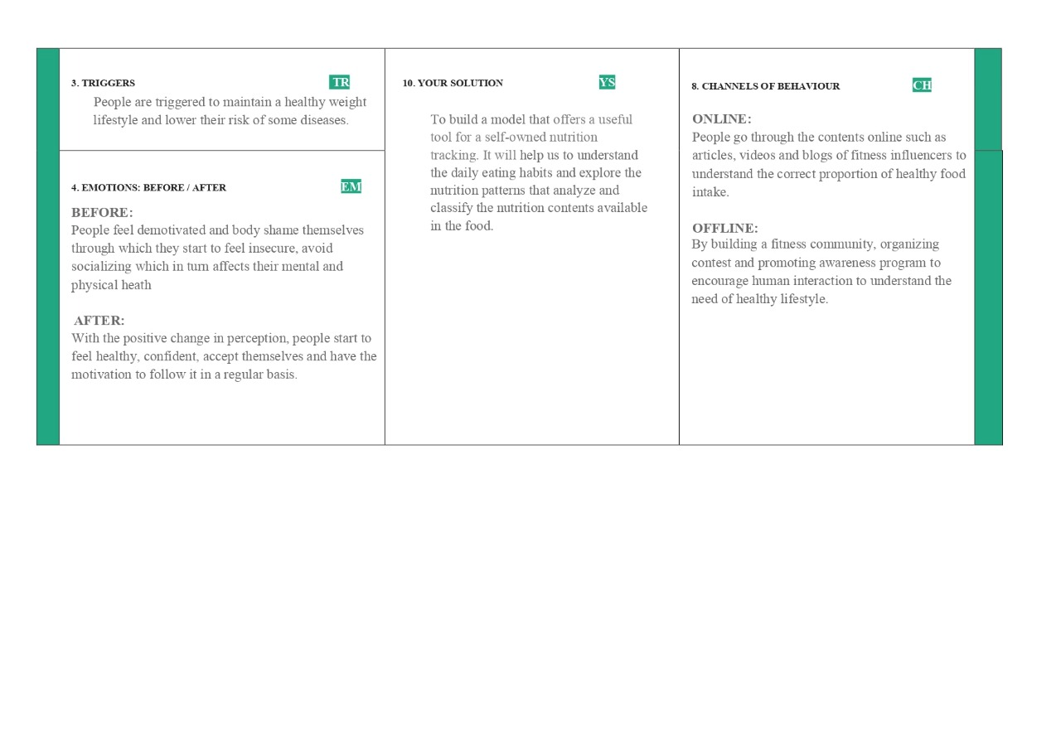

**4. REQUIREMENT ANALYSIS**

**4.1 FUNCTIONAL REQUIREMENT**

|  |  |  |
| --- | --- | --- |
| **FR No.** | **Functional Requirement (Epic)** | **Sub Requirement (Story / Sub-Task)** |
| FR-1 | User Registration | Registration through Form  Registration through Gmail Registration through LinkedIn |
| FR-2 | User Confirmation | Confirmation via Email Confirmation via OTP |
| FR-3 | User Login | Login through Google Login through Email |
| FR-4 | Choose package | Selection of desired package |
| FR-5 | Generate the daily plan | Daily plans will be generated by dietician |
| FR-6 | Manage progress report | Gathering information from database and generating report |
| FR-7 | Query | The user can ask for changes in plan. |

**4.2 NON FUNCTIONAL REQUIREMENT**

|  |  |  |
| --- | --- | --- |
| **FR No.** | **Non-Functional Requirement** | **Description** |
| NFR-1 | Usability | Easy to use with interactive User Interface |
| NFR-2 | Security | User can access only their personal information and not that of other users. |
| NFR-3 | Reliability | The average time of failure shall be 7 days |
| NFR-4 | Performance | The results has to be shown within 10 sec |
| NFR-5 | Availability | The dietician shall be available to users 24 hours a day, 7 days a week. |
| NFR-6 | Scalability | Supports various food items |

1. **PROJECT DESIGN**
   1. **DATA FLOW DIAGRAM**

**DFD-1 (Login):**

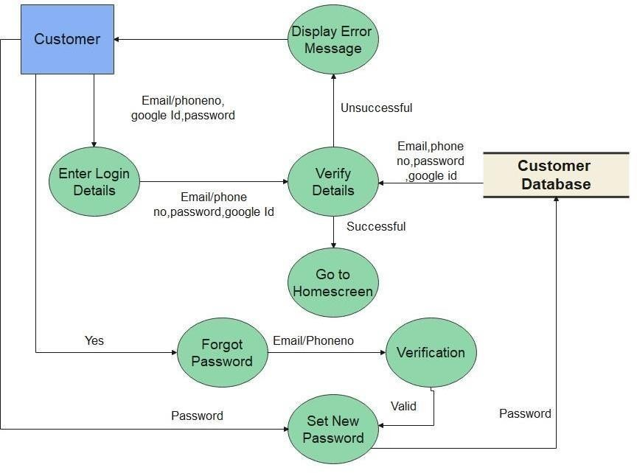

**DFD-2 (Registration):**

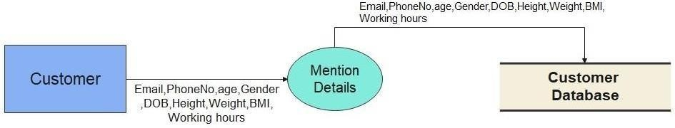

**DFD-3(Payment):**

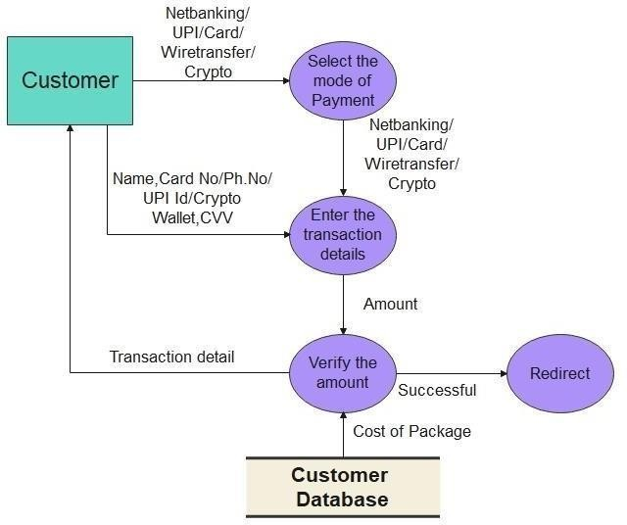

1. **PROJECT PLANNING AND ESTIMATION**
   1. **SPRINT PLANNING AND ESTIMATION**

|  |  |  |  |  |  |  |
| --- | --- | --- | --- | --- | --- | --- |
| **Sprint** | **Functional Requirement (Epic)** | **User Story Number** | **User story / Task** | **Story Points** | **Priority** | **Team Members** |
| Sprint-1 | Data Collection | USN-1 | Dataset - Collecting images of food items like apple, orange, grapes, banana for analysis | 4 | High | Nisha Rasaili |
| Sprint-1 | Image Preprocessing | USN-2 | Image data augmentation - Increasing the amount of data by generating new data points from existing data | 3 | Medium | Malini R |
| Sprint-1 | USN-3 | Image Data Generator Class - Used for getting the input of the original data | 3 | Medium | Mathangi Sriraman |
| Sprint-1 | USN-4 | Applying image data generator functionality to train-set and test-set | 5 | Medium | Sriman Narayanan P G |
| Sprint-1 | Modeling Phase | USN-5 | Defining the model architecture  - Building the model using deep learning approach and adding CNN layers | 5 | High | Malini R |
| Sprint-2 | USN-6 | Training , saving, testing and predicting the model | 5 | High | Sriman Narayanan P G |
| Sprint-2 | USN-7 | Database creation for the input classes | 3 | High | Mathangi Sriraman |
| Sprint-2 | Development Phase | USN-8 | Home page creation - It shows options of the application | 4 | Medium | Nisha Rasaili |
| Sprint-2 | USN-9 | User database creation - It contains the details of users | 3 | Low | Sriman Narayanan P G |
| Sprint-2 | USN-10 | Login and registration page creation - User can register and login through g mail with Id and password | 5 | Low | Mathangi Sriraman |
| Sprint-3 | USN-11 | Dashboard creation - Dashboard contains the information of user profile and features of the application | 3 | Low | Nisha Rasaili |

|  |  |  |  |  |  |  |
| --- | --- | --- | --- | --- | --- | --- |
| Sprint-3 | Development Phase | USN-12 | User Input Page Creation - It is for the user to feed the input images | 4 | Low | Sriman Narayanan P G |
| Sprint-3 | USN-13 | Analysis and prediction page creation - It shows the prediction of given user input | 4 | Medium | Malini R |
| Sprint-3 | USN-14 | Creation of about us, feedback and rating page – It shows application history and feedback page to users | 4 | Medium | Nisha Rasaili |
| Sprint-3 | Application Phase | USN-15 | Building the python code and importing the flask module into the project | 5 | Medium | Malini R |
| Sprint-4 | USN-16 | Create the Flask application and loading the model | 4 | High | Mathangi Sriraman |
| Sprint-4 | USN-17 | API integration - Connecting front end and back end and perform routing and run the application | 4 | High | Sriman Narayanan P G |
| Sprint-4 | Deployment Phase | USN-18 | Cloud deployment – Deployment of application by using IBM cloud | 4 | High | Malini R |
| Sprint-4 | Testing Phase | USN-19 | Functional testing – Checking usability and accessibility | 4 | High | Mathangi Sriraman |
| Sprint-4 | USN-20 | Non Functional testing – Checking scalability and performance of the application | 4 | High | Nisha Rasaili |

**6.2 SPRINT DELIVERY PLAN**

|  |  |  |  |  |  |  |
| --- | --- | --- | --- | --- | --- | --- |
| **Sprint** | **Total Story Points** | **Duration** | **Sprint Start Date** | **Sprint End Date (Planned)** | **Story Points Completed (as on Planned End Date)** | **Sprint Release Date(Actual)** |
| Sprint-1 | 20 | 5 Days | 17 Oct 2022 | 21 Oct 2022 | 20 | 21 Oct 2022 |
| Sprint-2 | 20 | 5 Days | 22 Oct 2022 | 26 Oct 2022 | 20 | 26 Oct 2022 |
| Sprint-3 | 20 | 5 Days | 27 Oct 2022 | 31 Oct 2022 | 20 | 31 Oct 2022 |
| Sprint-4 | 20 | 5 Days | 01 Nov 2022 | 05 Nov 2022 | 20 | 05 Nov 2022 |